The prototype for the Mercado Escolar Shopping Web Application consists of the following interfaces



***Mercado Escolar***

***Students Shopping Platform***

Mercado Escolar

Search

**Home About Services Blog Contact**

Mercado Escolar

We have all you need

Just order, we deliver

User Login

User Name:

Password:

[Forgot Password](Prototype.docx)  [Register](Prototype.docx)



Login



Figure 1 Home Page

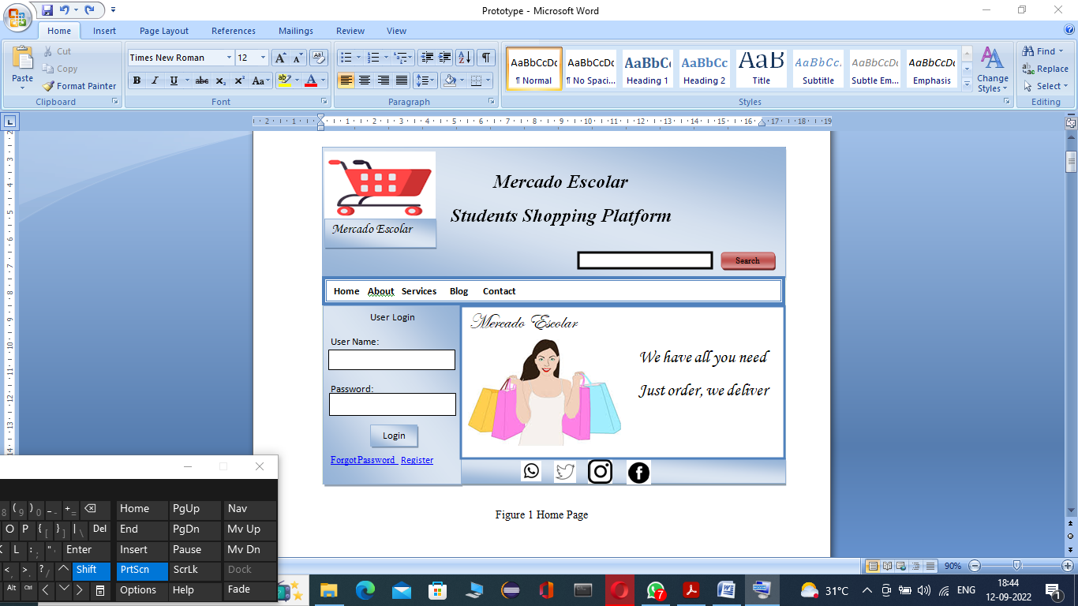

View

Buy



Buy

View



View

Buy



Product: Book Product: Laptop Product: 1 Plus 5

Price: $15 Price: $1500 Price: $500

Chose from our products and we deliver to your door step

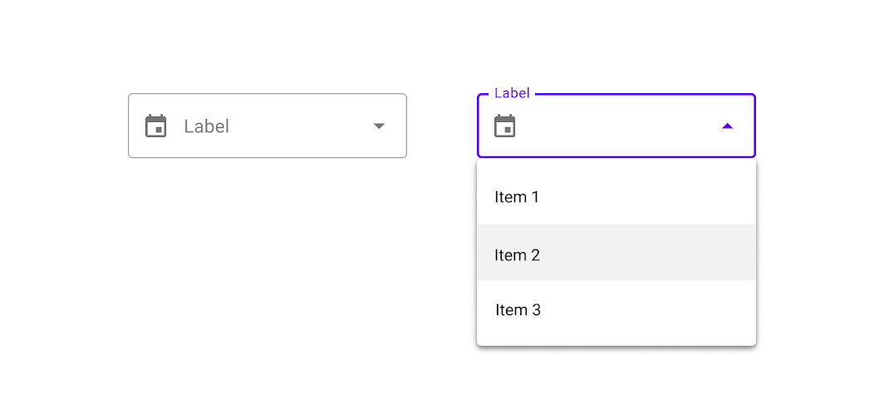

Figure 2 Product Table

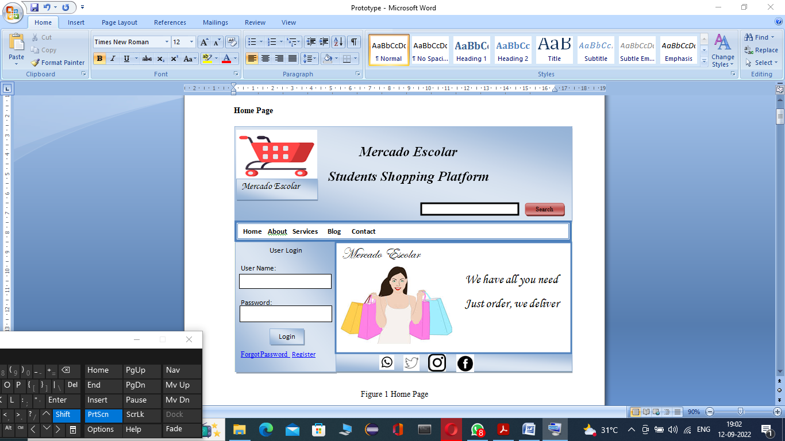Figure 3 Student Page



Tea glass

Phone

Chair

Laptop

Dance

Football

Racingl

Drama

Hi every one

Post New/Delete

Clubs Create/Delete

Product Add/Remove

Welcome: Johson Brandy

Category: Student

[Logout](Prototype.docx)

Figure 4 Super Admin Page

School_Admin Add/Delete

Students Add/Delete

Welcome: Srikar Dupatti

Category: Super Admin

[Logout](Prototype.docx)



Business Owner Add/Delete

Students Add/Delete

Welcome: Antony Johnson

Category: School Admin

[Logout](Prototype.docx)

Figure 5 School Admin Page

Figure 6 Business Owner Page

Chart

Chart

Order

Students

Welcome: Sridar S.

Category: Business Owner

[Logout](Prototype.docx)



*About Mercado Escolar*

*Mercado Escolar is a platform for students to buy and sell their products. Students can create clubs like football club, drama club, dance club and join clubs of their interest. They can advertise their products, post comments and view comments posted by their fellow students*.

Figure 7 About Mercado Escolar



Cancel

Send

*Contact Us*

*Your Name*

*Your Email*

*Subject*

*Complain*

Figure 8 Contact Us Page



Cancel

Register

*Student Registration Page*

*Your Name*

*Email*

*Address*

*Phone_No*

Figure 9 Student Registration



Cancel

Register

*Business Owner Registration Page*

*Your Name*

*Email*

*Address*

*Phone_No*

Figure 10 Business Owner Registration Page